**Tech Titans**

**Jazmine, Yammie, Marcus, Oscar, Mustafa**

**A06 TensorFlow Playground**

**Patricia McManus**

**A06: Exploring Neural Networks with TensorFlow Playground**

**Introduction to Neural Networks**

What are Neural Networks?

Neural networks are computational models inspired by the structure and function of the human brain. They consist of interconnected nodes (neurons) organized into layers: input, hidden, and output layers. Each neuron processes input data, applies a weight, adds a bias, and then uses an activation function to produce an output.

**Key Components of Neural Networks**

* Neurons: Basic units that process inputs and generate outputs.
* Layers: Organized collections of neurons (input, hidden, output).
* Activation Functions: Mathematical functions that determine neuron outputs, such as ReLU (Rectified Linear Unit) and sigmoid.

**Significance of Neural Networks**

Neural networks are crucial for various tasks such as pattern recognition, image classification, regression, and decision-making. They enable machines to learn from data and make predictions or decisions based on that learning.

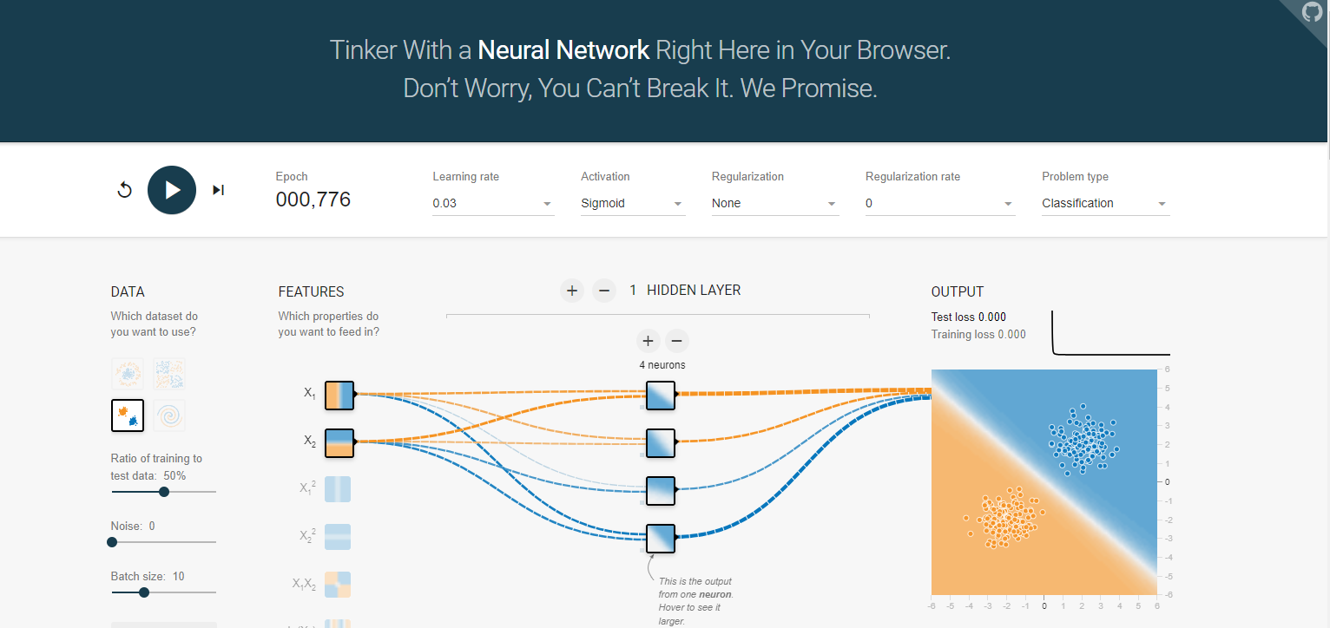

**References:**

Goodfellow, I., Bengio, Y., & Courville, A. (2016). Deep Learning. MIT Press.

Nielsen, M. (2015). Neural Networks and Deep Learning. Determination Press.

**Exploration Phase**

* Access TensorFlow Playground
* Visit TensorFlow Playground.

**Tasks and Observations**

**Task 1: Activation Functions**

Experiment

Create a neural network with one hidden layer and test different activation functions (ReLU, sigmoid, tanh).

Explanation

Activation Functions:

* ReLU (Rectified Linear Unit): Allows gradients to flow through the network when the input is positive, helping mitigate the vanishing gradient problem.
* Sigmoid: Maps inputs to a range [0, 1], useful for probabilities but can cause vanishing gradient issues.
* Tanh (Hyperbolic Tangent): Maps inputs to a range [-1, 1], which helps in centering the data and often performs better than sigmoid.

Observations

ReLU: Faster training and better performance in deep networks.

Sigmoid: Slower training, potential vanishing gradient problems.

Tanh: Better than sigmoid due to its output range, helping in some cases with convergence.

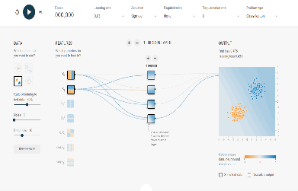 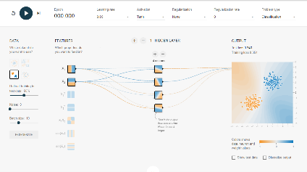 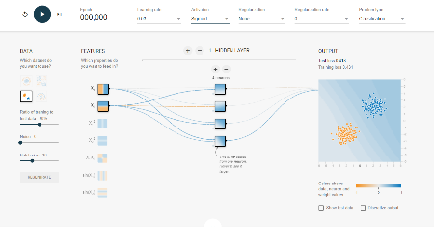

**References:**

Goodfellow, I., Bengio, Y., & Courville, A. (2016). Deep Learning. MIT Press.

**Task 2: Hidden Layer Neurons**

Experiment

Change the number of neurons in the hidden layer and add more hidden layers.

Explanation

Role of Neurons and Layers:

* Neurons: Process inputs and generate outputs.
* Hidden Layers: Enable the network to learn complex patterns by combining inputs in various ways.

Observations

Increasing Neurons: More capacity to learn detailed representations, but risk of overfitting.

Adding Hidden Layers: Allows learning of more abstract representations, but too many layers can increase training time and overfitting risk.

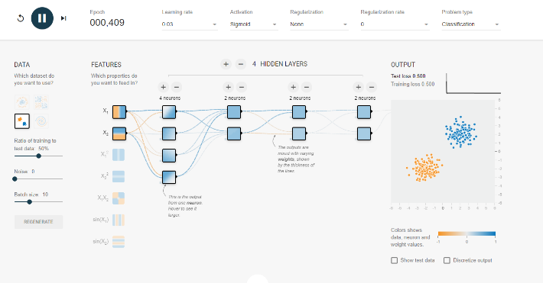

References:

Nielsen, M. (2015). Neural Networks and Deep Learning. Determination Press.

**Task 3: Learning Rate**

Experiment

Adjust the learning rate slider.

Explanation

Learning Rate:

* Definition: Controls how much to change the model in response to the error each time the model weights are updated.
* Significance: Determines the size of the steps the optimization algorithm takes towards the minimum of the loss function.

Observations

High Learning Rate: Fast convergence but may overshoot the minimum, causing instability.

Low Learning Rate: Slow convergence but more precise adjustment towards the minimum.

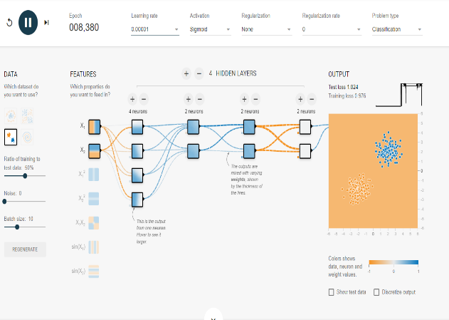 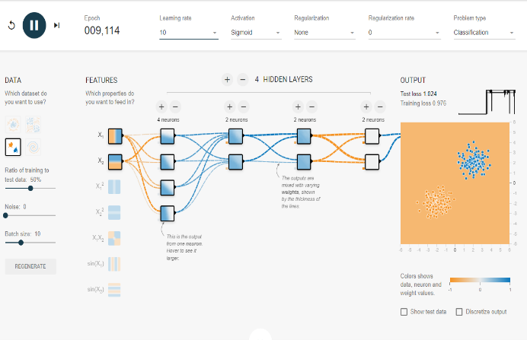

References:

Goodfellow, I., Bengio, Y., & Courville, A. (2016). Deep Learning. MIT Press.

**Task 4: Data Noise**

Experiment

Introduce noise using the “Noise” slider.

Explanation

Data Noise:

Definition: Random variations or disturbances in the input data not part of the true signal.

Impact: High noise can make it harder for the network to generalize, as it might learn to fit the noise instead of the underlying pattern.

Observations

Generalization: Introducing noise can reduce the network's ability to generalize from the training data to unseen data.

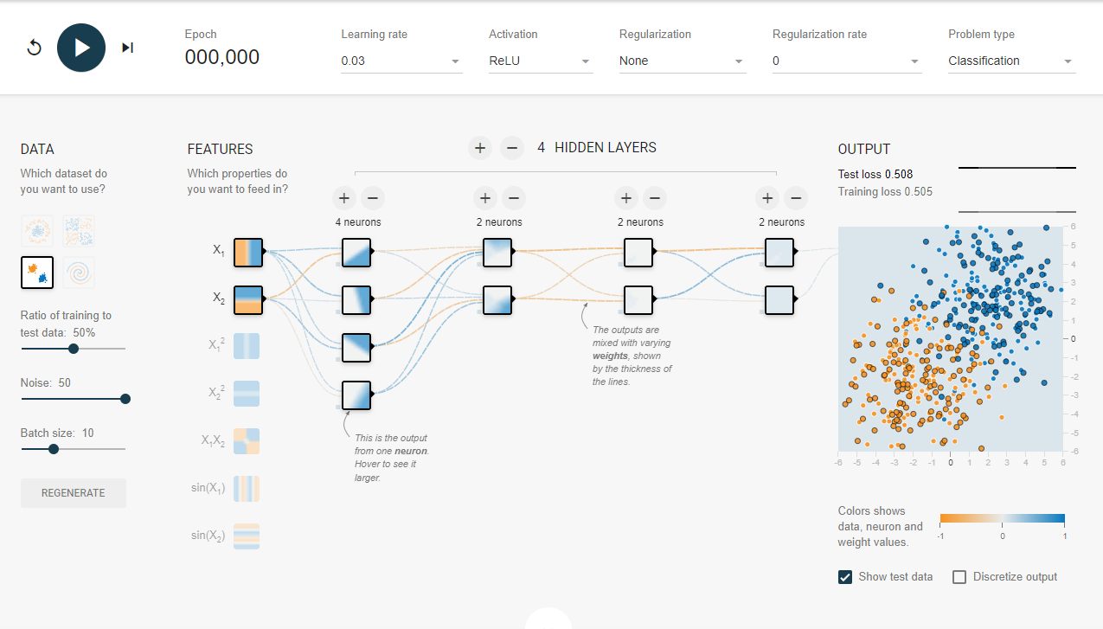

References:

Nielsen, M. (2015). Neural Networks and Deep Learning. Determination Press.

**Task 5: Dataset Exploration**

Experiment

Use different datasets available in TensorFlow Playground.

Explanation

Datasets:

* Describe each dataset and its significance.
* Analyze network performance on each dataset.

Observations

Different Datasets: Highlight the network's strengths and weaknesses depending on the dataset used.

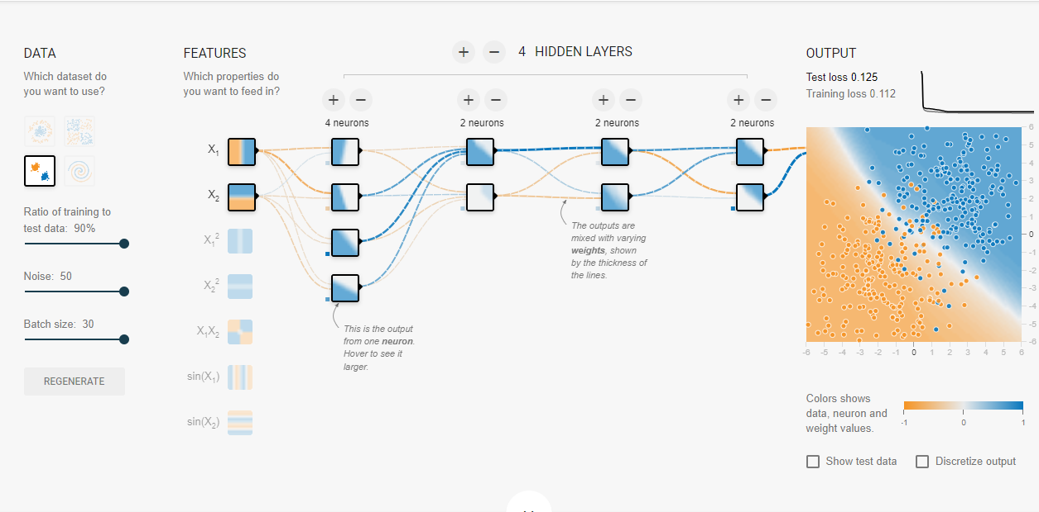

References:

Goodfellow, I., Bengio, Y., & Courville, A. (2016). Deep Learning. MIT Press.

**Group Report**

Neural networks are computational models inspired by the human brain, consisting of neurons and layers. They are significant for tasks such as pattern recognition and decision-making.

* For Task 1, we tested different activation functions, including ReLU, sigmoid, and tanh, and observed their effects on training speed and performance. ReLU often led to faster training and better performance due to its ability to mitigate the vanishing gradient problem. Sigmoid and tanh had slower training times, with sigmoid sometimes causing vanishing gradient issues, while tanh performed better due to its output range.
* In Task 2, we changed the number of neurons in the hidden layer and the number of hidden layers to observe their impact on the network's performance. Increasing the number of neurons enhanced the network's capacity to learn detailed representations but also increased the risk of overfitting. Adding more hidden layers allowed the network to learn more abstract representations, but too many layers led to increased training time and potential overfitting.
* For Task 3, we adjusted the learning rate to understand its impact on convergence speed and accuracy. A high learning rate resulted in faster convergence but sometimes caused instability by overshooting the minimum. Conversely, a low learning rate provided more precise adjustments but slowed down the convergence process.
* In Task 4, we introduced data noise using the “Noise” slider and analyzed its impact on the network's ability to generalize. Higher noise levels made it harder for the network to generalize from the training data to unseen data, reducing overall performance.

During Task 5, we explored different datasets available in TensorFlow Playground and documented the network's performance on each. The variations in datasets highlighted the network's adaptability and robustness, showcasing its strengths and weaknesses depending on the data used.

**Parameter Effects**

The experiments demonstrated that ReLU activation functions improve performance by mitigating vanishing gradients. Increasing the number of neurons and hidden layers enhances learning capacity but also raises the risk of overfitting. The learning rate needs to be balanced; high rates speed up training but can cause instability, while low rates ensure precise adjustments but slow down the process. Introducing higher levels of data noise reduces the network's ability to generalize, and different datasets reveal the network's adaptability and robustness.

**Practical Implications**

Understanding these parameters is crucial for developing effective neural networks applicable to real-world scenarios such as image classification and decision-making systems. By adjusting activation functions, neuron counts, hidden layers, learning rates, and handling data noise appropriately, we can optimize neural networks for various applications.

**Conclusion**

Through this hands-on experience with TensorFlow Playground, we learned how different parameters affect neural network performance. Balancing learning rates and managing data noise were among the challenges we faced, which we overcame through iterative testing and observation. This exploration provided valuable insights into optimizing neural networks for practical applications.

**References:**

Goodfellow, I., Bengio, Y., & Courville, A. (2016). Deep Learning. MIT Press.

Nielsen, M. (2015). Neural Networks and Deep Learning. Determination Press.

TensorFlow Playground documentation.